What Is Fuzzy Logic?
The past few years have witnessed a rapid growth in the number and variety of applications of fuzzy logic. The applications range from consumer products such as cameras, camcorders, washing machines, and microwave ovens to industrial process control, medical instrumentation, decision-support systems, and portfolio selection.
To understand the reasons for the growing use of fuzzy logic it is necessary, first, to clarify what is meant by fuzzy logic.
Fuzzy logic has two different meanings. In a narrow sense, fuzzy logic is a logical system, which is an extension of multivalued logic. But in a wider sense, which is in predominant use today, fuzzy logic (FL) is almost synonymous with the theory of fuzzy sets, a theory which relates to classes of objects with unsharp boundaries in which membership is a matter of degree. In this perspective, fuzzy logic in its narrow sense is a branch of FL. What is important to recognize is that, even in its narrow sense, the agenda of fuzzy logic is very different both in spirit and substance from the agendas of traditional multivalued logical systems.
In the Fuzzy Logic Toolbox, fuzzy logic should be interpreted as FL, that is, fuzzy logic in its wide sense. The basic ideas underlying FL are explained very clearly and insightfully in the Introduction. What might be added is that the basic concept underlying FL is that of a linguistic variable, that is, a variable whose values are words rather than numbers. In effect, much of FL may be viewed as a methodology for computing with words rather than numbers. Although words are inherently less precise than numbers, their use is closer to human intuition. Furthermore, computing with words exploits the tolerance for imprecision and thereby lowers the cost of solution.
Another basic concept in FL, which plays a central role in most of its applications, is that of a fuzzy if-then rule or, simply, fuzzy rule. Although rule-based systems have a long history of use in AI, what is missing in such systems is a machinery for dealing with fuzzy consequents and/or fuzzy antecedents. In fuzzy logic, this machinery is provided by what is called the calculus of fuzzy rules. The calculus of fuzzy rules serves as a basis for what might be called the Fuzzy Dependency and Command Language (FDCL). Although FDCL is not used explicitly in the Fuzzy Logic Toolbox, it is effectively one of its principal constituents. In this connection, what is important to recognize is that in most of the applications of fuzzy logic, a fuzzy logic solution is in reality a translation of a human solution into FDCL.
A trend that is growing in visibility relates to the use of fuzzy logic in combination with neurocomputing and genetic algorithms. More generally, fuzzy logic, neurocomputing, and genetic algorithms may be viewed as the principal constituents of what might be called soft computing. Unlike the traditional, hard computing, soft computing is aimed at an accommodation with the pervasive imprecision of the real world. The guiding principle of soft computing is: Exploit the tolerance for imprecision, uncertainty, and partial truth to achieve tractability, robustness, and low solution cost. In coming years, soft computing is likely to play an increasingly important role in the conception and design of systems whose MIQ (Machine IQ) is much higher than that of systems designed by conventional methods.
Among various combinations of methodologies in soft computing, the one that has highest visibility at this juncture is that of fuzzy logic and neurocomputing, leading to so-called neuro-fuzzy systems. Within fuzzy logic, such systems play a particularly important role in the induction of rules from observations. An effective method developed by Dr. Roger Jang for this purpose is called ANFIS (Adaptive Neuro-Fuzzy Inference System). This method is an important component of the Fuzzy Logic Toolbox.
Fuzzy logic is all about the relative importance of precision: How important is it to be exactly right when a rough answer will do? All books on fuzzy logic begin with a few good quotes on this very topic, and this is no exception. Here is what some clever people have said in the past.
Precision is not truth.
— Henri Matisse
Sometimes the more measurable drives out the most important.
— René Dubos
Vagueness is no more to be done away with in the world of logic than friction in mechanics.
— Charles Sanders Peirce
I believe that nothing is unconditionally true, and hence I am opposed to every statement of positive truth and every man who makes it.
— H. L. Mencken
So far as the laws of mathematics refer to reality, they are not certain. And so far as they are certain, they do not refer to reality.
— Albert Einstein
As complexity rises, precise statements lose meaning and meaningful statements lose precision.
— Lotfi Zadeh
Some pearls of folk wisdom also echo these thoughts.
Don't lose sight of the forest for the trees.
Don't be penny wise and pound foolish.
The Fuzzy Logic Toolbox for use with MATLAB is a tool for solving problems with fuzzy logic. Fuzzy logic is a fascinating area of research because it does a good job of trading off between significance and precision — something that humans have been managing for a very long time.
Fuzzy logic sometimes appears exotic or intimidating to those unfamiliar with it, but once you become acquainted with it, it seems almost surprising that no one attempted it sooner. In this sense fuzzy logic is both old and new because, although the modern and methodical science of fuzzy logic is still young, the concepts of fuzzy logic reach right down to our bones.
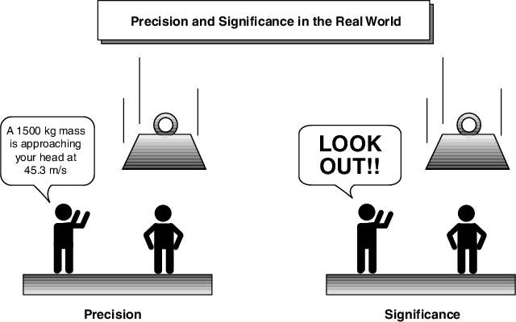
Fuzzy logic is a convenient way to map an input space to an output space. This is the starting point for everything else, and the great emphasis here is on the word "convenient."
What do I mean by mapping input space to output space? Here are a few examples: You tell me how good your service was at a restaurant, and I'll tell you what the tip should be. You tell me how hot you want the water, and I'll adjust the faucet valve to the right setting. You tell me how far away the subject of your photograph is, and I'll focus the lens for you. You tell me how fast the car is going and how hard the motor is working, and I'll shift the gears for you.
A graphical example of an input-output map is shown below.
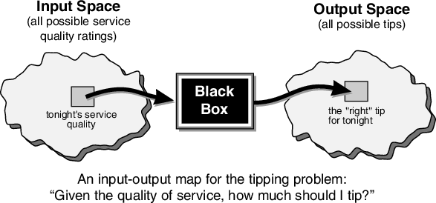
It's all just a matter of mapping inputs to the appropriate outputs. Between the input and the output we'll put a black box that does the work. What could go in the black box? Any number of things: fuzzy systems, linear systems, expert systems, neural networks, differential equations, interpolated multidimensional lookup tables, or even a spiritual advisor, just to name a few of the possible options. Clearly the list could go on and on.
Of the dozens of ways to make the black box work, it turns out that fuzzy is often the very best way. Why should that be? As Lotfi Zadeh, who is considered to be the father of fuzzy logic, once remarked: "In almost every case you can build the same product without fuzzy logic, but fuzzy is faster and cheaper."

Why Use Fuzzy Logic?
Here is a list of general observations about fuzzy logic:
- Fuzzy logic is conceptually easy to understand.
The mathematical concepts behind fuzzy reasoning are very simple. What makes fuzzy nice is the "naturalness" of its approach and not its far-reaching complexity.
- Fuzzy logic is flexible.
With any given system, it's easy to massage it or layer more functionality on top of it without starting again from scratch.
- Fuzzy logic is tolerant of imprecise data.
Everything is imprecise if you look closely enough, but more than that, most things are imprecise even on careful inspection. Fuzzy reasoning builds this understanding into the process rather than tacking it onto the end.
- Fuzzy logic can model nonlinear functions of arbitrary complexity.
You can create a fuzzy system to match any set of input-output data. This process is made particularly easy by adaptive techniques like Adaptive Neuro-Fuzzy Inference Systems (ANFIS), which are available in the Fuzzy Logic Toolbox.
- Fuzzy logic can be built on top of the experience of experts.
In direct contrast to neural networks, which take training data and generate opaque, impenetrable models, fuzzy logic lets you rely on the experience of people who already understand your system.
- Fuzzy logic can be blended with conventional control techniques.
Fuzzy systems don't necessarily replace conventional control methods. In many cases fuzzy systems augment them and simplify their implementation.
- Fuzzy logic is based on natural language.
The basis for fuzzy logic is the basis for human communication. This observation underpins many of the other statements about fuzzy logic.
The last statement is perhaps the most important one and deserves more discussion. Natural language, that which is used by ordinary people on a daily basis, has been shaped by thousands of years of human history to be convenient and efficient. Sentences written in ordinary language represent a triumph of efficient communication. We are generally unaware of this because ordinary language is, of course, something we use every day. Since fuzzy logic is built atop the structures of qualitative description used in everyday language, fuzzy logic is easy to use.

When Not to Use Fuzzy Logic
Fuzzy logic is not a cure-all. When should you not use fuzzy logic? The safest statement is the first one made in this introduction: fuzzy logic is a convenient way to map an input space to an output space. If you find it's not convenient, try something else. If a simpler solution already exists, use it. Fuzzy logic is the codification of common sense — use common sense when you implement it and you will probably make the right decision. Many controllers, for example, do a fine job without using fuzzy logic. However, if you take the time to become familiar with fuzzy logic, you'll see it can be a very powerful tool for dealing quickly and efficiently with imprecision and nonlinearity.

What Can the Fuzzy Logic Toolbox Do?
The Fuzzy Logic Toolbox allows you to do several things, but the most important thing it lets you do is create and edit fuzzy inference systems. You can create these systems using graphical tools or command-line functions, or you can generate them automatically using either clustering or adaptive neuro-fuzzy techniques.
If you have access to Simulink, you can easily test your fuzzy system in a block diagram simulation environment.
The toolbox also lets you run your own stand-alone C programs directly, without the need for Simulink. This is made possible by a stand-alone Fuzzy Inference Engine that reads the fuzzy systems saved from a MATLAB session. You can customize the stand-alone engine to build fuzzy inference into your own code. All provided code is ANSI compliant.
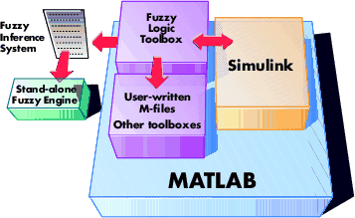
Because of the integrated nature of the MATLAB environment, you can create your own tools to customize the Fuzzy Logic Toolbox or harness it with another toolbox, such as the Control System Toolbox, Neural Network Toolbox, or Optimization Toolbox, to mention only a few of the possibilities.

An Introductory Example: Fuzzy vs. Nonfuzzy
A specific example would be helpful at this point. To illustrate the value of fuzzy logic, we'll show two different approaches to the same problem: linear and fuzzy. First we will work through this problem the conventional (nonfuzzy) way, writing MATLAB commands that spell out linear and piecewise-linear relations. Then we'll take a quick look at the same system using fuzzy logic.
Consider the tipping problem: what is the right amount to tip your waitperson? Here is a clear statement of the problem.
The Basic Tipping Problem. Given a number between 0 and 10 that represents the quality of service at a restaurant (where 10 is excellent), what should the tip be?
Note This problem is based on tipping as it is typically practiced in the United States. An average tip for a meal in the U.S. is 15%, though the actual amount may vary depending on the quality of the service provided

The Nonfuzzy Approach
Let's start with the simplest possible relationship. Suppose that the tip always equals 15% of the total bill.
tip = 0.15
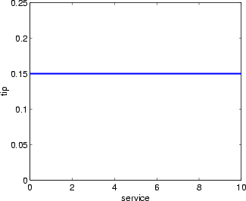
This doesn't really take into account the quality of the service, so we need to add a new term to the equation. Since service is rated on a scale of 0 to 10, we might have the tip go linearly from 5% if the service is bad to 25% if the service is excellent. Now our relation looks like this.
tip=0.20/10*service+0.05
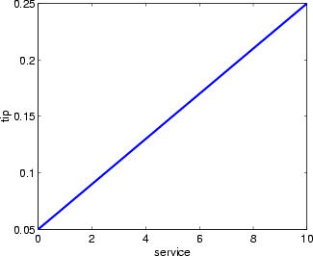
So far so good. The formula does what we want it to do, and it's pretty straightforward. However, we may want the tip to reflect the quality of the food as well. This extension of the problem is defined as follows.
The Extended Tipping Problem. Given two sets of numbers between 0 and 10 (where 10 is excellent) that respectively represent the quality of the service and the quality of the food at a restaurant, what should the tip be?
Let's see how the formula will be affected now that we've added another variable. Suppose we try
tip = 0.20/20*(service+food)+0.05;
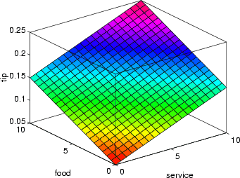
In this case, the results look pretty, but when you look at them closely, they don't seem quite right. Suppose you want the service to be a more important factor than the food quality. Let's say that the service will account for 80% of the overall tipping grade and the food will make up the other 20%. Try
servRatio=0.8;
tip=servRatio*(0.20/10*service+0.05) + ...
(1-servRatio)*(0.20/10*food+0.05);
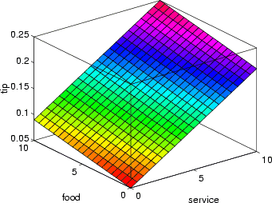
The response is still somehow too uniformly linear. Suppose you want more of a flat response in the middle, i.e., you want to give a 15% tip in general, and will depart from this plateau only if the service is exceptionally good or bad. This, in turn, means that those nice linear mappings no longer apply. We can still salvage things by using a piecewise linear construction. Let's return to the one-dimensional problem of just considering the service. You can string together a simple conditional statement using breakpoints like this.
if service<3,
tip=(0.10/3)*service+0.05;
elseif service<7,
tip=0.15;
elseif service<=10,
tip=(0.10/3)*(service-7)+0.15;
end
The plot now looks like the figure below.
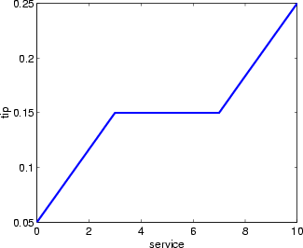
If we extend this to two dimensions, where we take food into account again, something like this results.
servRatio=0.8;
if service<3,
tip=((0.10/3)*service+0.05)*servRatio + ...
(1-servRatio)*(0.20/10*food+0.05);
elseif service<7,
tip=(0.15)*servRatio + ...
(1-servRatio)*(0.20/10*food+0.05);
else,
tip=((0.10/3)*(service-7)+0.15)*servRatio + ...
(1-servRatio)*(0.20/10*food+0.05);
end
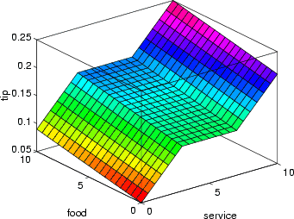
The plot looks good, but the function is surprisingly complicated. It was a little tricky to code this correctly, and it's definitely not easy to modify this code in the future. Moreover, it's even less apparent how the algorithm works to someone who didn't witness the original design process.

The Fuzzy Approach
It would be nice if we could just capture the essentials of this problem, leaving aside all the factors that could be arbitrary. If we make a list of what really matters in this problem, we might end up with the following rule descriptions.
- If service is poor, then tip is cheap
- If service is good, then tip is average
- If service is excellent, then tip is generous
The order in which the rules are presented here is arbitrary. It doesn't matter which rules come first. If we wanted to include the food's effect on the tip, we might add the following two rules.
- If food is rancid, then tip is cheap
- If food is delicious, then tip is generous
In fact, we can combine the two different lists of rules into one tight list of three rules like so.
- If service is poor or the food is rancid, then tip is cheap
- If service is good, then tip is average
- If service is excellent or food is delicious, then tip is generous
These three rules are the core of our solution. And coincidentally, we've just defined the rules for a fuzzy logic system. Now if we give mathematical meaning to the linguistic variables (what is an average tip, for example?) we would have a complete fuzzy inference system. Of course, there's a lot left to the methodology of fuzzy logic that we're not mentioning right now, things such as:
- How are the rules all combined?
- How do I define mathematically what an average tip is?
The next few chapters provide detailed answers to these questions. The details of the method don't really change much from problem to problem — the mechanics of fuzzy logic aren't terribly complex. What matters is what we've shown in this preliminary exposition: fuzzy is adaptable, simple, and easily applied.
Here is the picture associated with the fuzzy system that solves this problem.
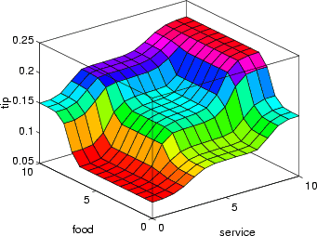
This picture was generated by the three rules above. The mechanics of how fuzzy inference works is explained in Overview, Foundations of Fuzzy Logic, and in Fuzzy Inference Systems. In Building Systems with the Fuzzy Logic Toolbox, the entire tipping problem is worked through using the graphical tools in the Fuzzy Logic Toolbox.

Observations
Here are some observations about the example so far. We found a piecewise linear relation that solved the problem. It worked, but it was something of a nuisance to derive, and once we wrote it down as code, it wasn't very easy to interpret. On the other hand, the fuzzy system is based on some common sense statements. Also, we were able to add two more rules to the bottom of the list that influenced the shape of the overall output without needing to undo what had already been done. In other words, the subsequent modification was pretty easy.
Moreover, by using fuzzy logic rules, the maintenance of the structure of the algorithm decouples along fairly clean lines. The notion of an average tip might change from day to day, city to city, country to country, but the underlying logic is the same: if the service is good, the tip should be average. You can recalibrate the method quickly by simply shifting the fuzzy set that defines average without rewriting the fuzzy rules.
You can do this sort of thing with lists of piecewise linear functions, but there is a greater likelihood that recalibration will not be so quick and simple.
For example, here is the piecewise linear tipping problem slightly rewritten to make it more generic. It performs the same function as before, only now the constants can be easily changed.
% Establish constants
lowTip=0.05; averTip=0.15; highTip=0.25;
tipRange=highTip-lowTip;
badService=0; okayService=3;
goodService=7; greatService=10;
serviceRange=greatService-badService;
badFood=0; greatFood=10;
foodRange=greatFood-badFood;

% If service is poor or food is rancid, tip is cheap
if service<okayService,
tip=(((averTip-lowTip)/(okayService-badService)) ...
*service+lowTip)*servRatio + ...
(1-servRatio)*(tipRange/foodRange*food+lowTip);
% If service is good, tip is average
elseif service<goodService,
tip=averTip*servRatio + (1-servRatio)* ...
(tipRange/foodRange*food+lowTip);
% If service is excellent or food is delicious, tip is generous
else,
tip=(((highTip-averTip)/ ...
(greatService-goodService))* ...
(service-goodService)+averTip)*servRatio + ...
(1-servRatio)*(tipRange/foodRange*food+lowTip);
end
Notice the tendency here, as with all code, for creeping generality to render the algorithm more and more opaque, threatening eventually to obscure it completely. What we're doing here isn't (shouldn't be!) that complicated. True, we can fight this tendency to be obscure by adding still more comments, or perhaps by trying to rewrite it in slightly more self-evident ways, but the medium is not on our side.
The truly fascinating thing to notice is that if we remove everything except for three comments, what remain are exactly the fuzzy rules we wrote down before.
% If service is poor or food is rancid, tip is cheap
% If service is good, tip is average
% If service is excellent or food is delicious, tip is generous
If, as with a fuzzy system, the comment is identical with the code, think how much more likely your code is to have comments. Fuzzy logic lets the language that is clearest to you, high level comments, also have meaning to the machine, which is why it is a very successful technique for bridging the gap between people and machines.
Or think of it this way. By making the equations as simple as possible (linear) we make things simpler for the machine but more complicated for us. But really the limitation is no longer the computer — it is our mental model of what the computer is doing. We all know that computers have the ability to make things hopelessly complex; fuzzy logic is really about reclaiming the middle ground and letting the machine work with our preferences rather than the other way around. It's about time.

